# Media Analysis - ChatGPT outperforms copywriters in STEP Conference’s outdoor adverts _ Updated 22 February 2023

## Short Summary

The article is about how STEP Conferences utilized ChatGPT to create more satisfactory outdoor ad taglines than their agency or internal team could, leading them to plan continued use of the AI tool for various content creation tasks, while discussing broader implications of AI on creative industries and job roles.

## Summary

- ChatGPT was used for creating taglines in STEP Conferences' outdoor adverts after initial dissatisfaction with agency and internal team outputs.  
- The company plans to continue using AI tools like ChatGPT by acquiring a paid account for content creation, summarization, and explanation across the team.  
- While AI poses potential threats to jobs, experts argue it can create more opportunities, noting that many future job roles have yet to be invented.  
- STEP's founder sees AI as complementary to human talent, acknowledging its dual role in enhancing creativity while potentially replacing some tasks.

## Question 1

The text frames the discussion around ChatGPT by highlighting its capabilities and impact on creative industries. Several metaphors and themes emerge:  
  
1. **Ominous Foretelling**: The use of AI in creative tasks is portrayed as a "future" or "ominous foretelling," suggesting significant changes ahead for traditional roles like copywriting.  
  
2. **Assistant or Complementary Tool**: ChatGPT is likened to an "artificial intelligence assistant" that enhances efficiency and creativity, indicating its supportive role rather than solely a replacement.  
  
3. **Creative Partner**: The framing suggests AI tools are seen as both complementary and competitive forces, balancing between assisting human creativity and potentially replacing certain job functions.  
  
These metaphors underscore the tension between technological advancement and traditional creative roles, highlighting both opportunities for innovation and concerns over job security in creative fields.

## Question 2

The text covers several perspectives and aspects regarding the use of ChatGPT in creative industries:  
  
1. **Performance and Efficiency**: It highlights how ChatGPT outperformed human copywriters in creating taglines for STEP Conferences' outdoor adverts, demonstrating its efficiency and utility as an AI tool.  
  
2. **Future of Creative Industries**: The text touches on concerns about the future of creative jobs due to AI advancements, with specific references to movies that explore similar themes.  
  
3. **Job Creation vs. Job Replacement**: There's a discussion on how AI might replace certain jobs while also potentially creating new ones, referencing expert opinions and statistics about future job trends.  
  
4. **Complementary Nature of AI Tools**: The founder of STEP Conference, Ray Dargham, suggests that AI tools can complement human creativity rather than entirely replace it, emphasizing the ongoing value of human creativity.  
  
5. **Adoption Strategy**: The article notes the company's plan to incorporate ChatGPT into its workflow as a supportive tool for content creation across various functions.  
  
Aspects being ignored or less covered include:  
  
1. **Ethical Considerations**: There is minimal discussion on ethical implications, such as data privacy concerns and potential biases in AI-generated content.  
  
2. **Impact on Employment**: Detailed effects on employment within the creative sector are not deeply explored beyond general statements about job replacement and creation.  
  
3. **Long-term Implications**: The text does not delve into long-term consequences for the advertising industry or how these tools might evolve over time.  
  
4. **User Experience**: There is little mention of how consumers perceive AI-generated content compared to human-created content, which could impact its effectiveness in marketing strategies.   
  
5. **Technical Limitations**: While ChatGPT's strengths are mentioned, any limitations it may have as an AI tool (e.g., lack of nuanced understanding or context) are not addressed.  
  
Overall, the text provides a balanced view of both potential benefits and challenges associated with integrating AI into creative processes but could expand on several critical areas.

## Question 3

The Arabic World is not specifically mentioned as playing a distinct role in this article regarding leveraging AI. The focus is primarily on STEP Conferences, which is based in Dubai, using ChatGPT for their creative processes, but there are no specific references to the broader Arabic World's involvement or strategies concerning AI.   
  
Answer: Not mentioned

## Question 4

The article discusses the use of ChatGPT in creating effective taglines for STEP Conferences' outdoor adverts, highlighting its efficiency and impact on creative processes. While acknowledging concerns about AI replacing jobs, it suggests that AI tools like ChatGPT complement human creativity rather than replace it entirely. The founder, Ray Dargham, believes these tools will make workflows more efficient but emphasizes the continued value of human creativity in adapting to new roles.

## Sentiment

The sentiment is 3.0

## Entities

Arab News, Art, STEP Conferences, Metas Open Pretrained Transformer, Googles Bard, Ray Dargham, STEP Conference, Dargham, Microsofts Bing, STEP, Dargham clari ed

## Highlights

#7cc867: 12

#f9cd59: 16

#c885da: 12

#fb5b89: 12

## Wordcloud for #7cc867 Highlights

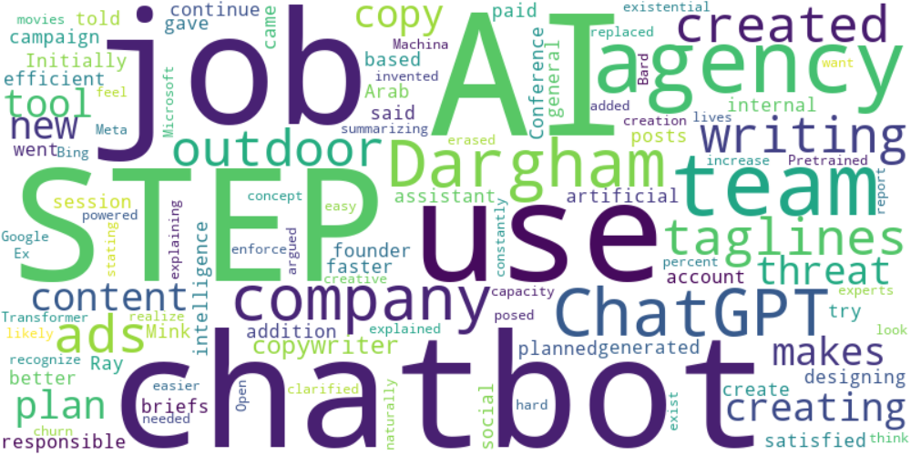

Top 10 words:

- AI: 6

- STEP: 5

- use: 4

- agency: 4

- team: 4

- like: 4

- Dargham: 3

- ChatGPT: 3

- company: 3

- chatbots: 3

## Wordcloud for #f9cd59 Highlights

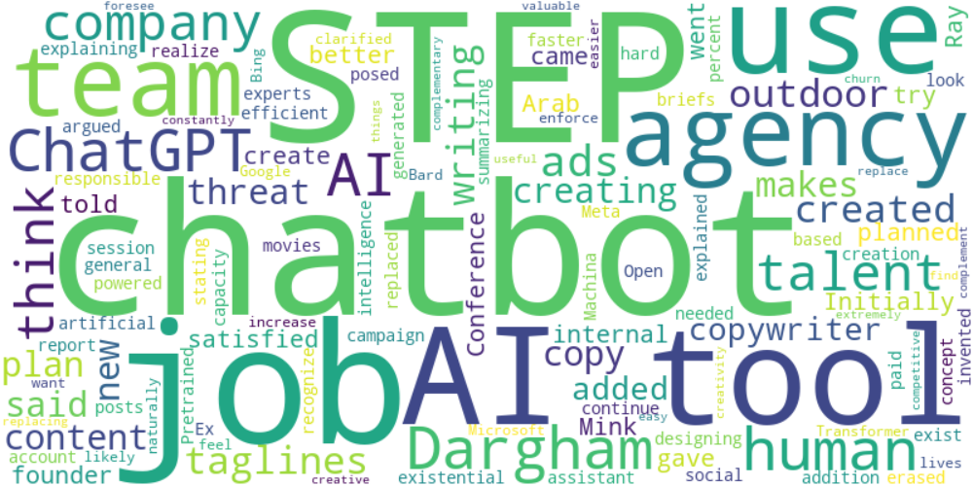

Top 10 words:

- AI: 9

- STEP: 5

- use: 4

- agency: 4

- team: 4

- Dargham: 4

- ChatGPT: 4

- like: 4

- tools: 4

- company: 3

## Wordcloud for #c885da Highlights



Top 10 words:

- AI: 6

- STEP: 5

- use: 4

- agency: 4

- team: 4

- like: 4

- Dargham: 3

- ChatGPT: 3

- company: 3

- chatbots: 3

## Wordcloud for #fb5b89 Highlights



Top 10 words:

- AI: 6

- STEP: 5

- use: 4

- agency: 4

- team: 4

- like: 4

- Dargham: 3

- ChatGPT: 3

- company: 3

- chatbots: 3